 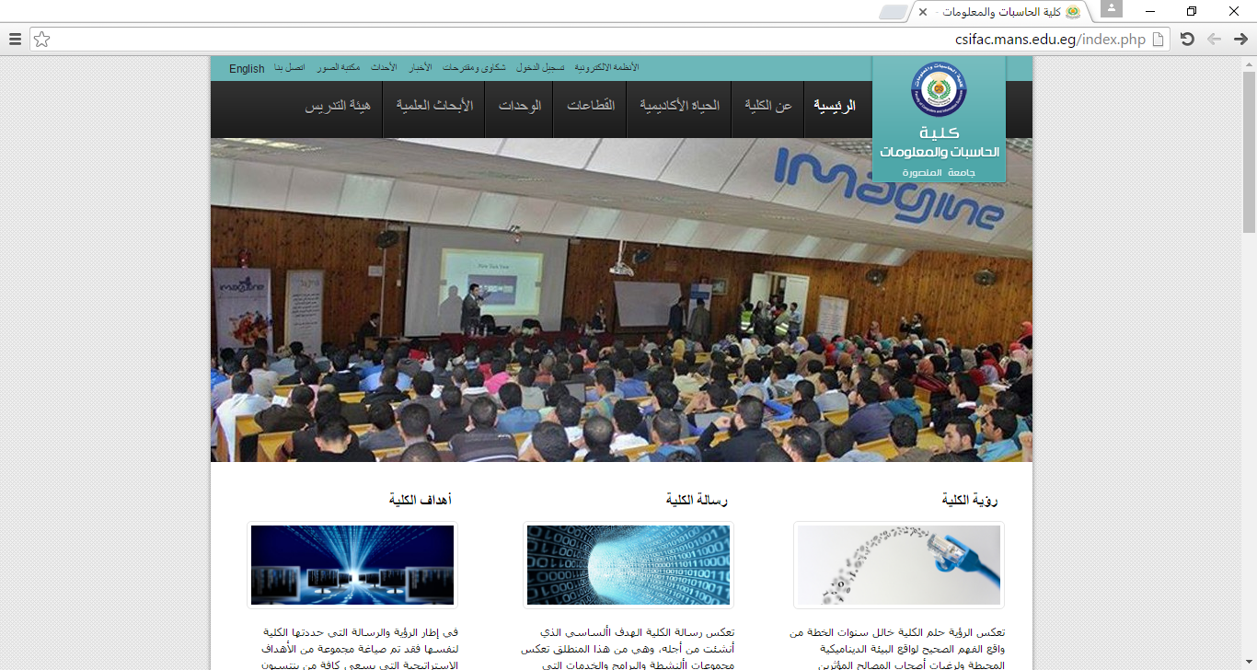

**Mansoura University Faculty of C&I.S**

|  |
| --- |
| **Faculty of Computer & Information Sciences Date: / 5 / 2018**  **Course title: Geographical Information Systems Time: 3 hours**  **Department of : Information Systems Semester: 2nd term , May 2018**  **4th Year Total Marks: 60 M Number of Pages: 5 pages** |

**Q1) Multiple-Choice Questions :**

* 1. **By ‘spatial data’ we mean data that has…………**

1. Complex values
2. Positional values
3. Graphic values
4. Decimal values
5. **User can use GIS to make………**
   1. complex analyses only
   2. display maps only
   3. complex analyses and display maps
   4. none of these

**3.Which of the following statements are true?**

1. Natural phenomena are usually fields
2. Man-made phenomena are usually objects
3. Both ‘A’ & ‘B’ are true
4. None of the above

**4. Topology refers to the**

a) input data error.

b) topographical analysis.

c) spatial relationship between geographic features.

d) surface of the earth.

e) logical sequence

**5. People use GIS because;**

a) it comes free with the Internet browser.

b) it is useful and efficient in analyzing spatial data.

c) it can read hard copy maps directly.

d) it is used widely.

e) it is linked directlyto GPS satellites.

* + 1. . **Which of the following list are appropriate definitions of scale?**

a) The ratio of a distance on a map to the corresponding distance on the ground.

|  |  |
| --- | --- |
|  | b) in indication of how big an object represented on the map is on the ground. |

c) A conversion factor used to transform map projections.

d) The lines on a map representing north-south and east-west directions.

e) The order of magnitude or level of generalization at which phenomena exist or are perceived or observed.

7.  **What does 1mm on a map drawn at a scale of 1:50,000 represent on the ground?**

1. 50 centimeters
2. 5 meters.
3. 500 centimeters.
4. 50 meters.

**8. The vector data model is based on which of the following?**

1. Collections of points joined by straight lines
2. Pixels or grid cells.
3. Cartesian coordinate system.

9. **Which of the following might be considered as the fourth dimension in GIS?**

1. Space b. Time C. Scale d. Location

10. **Which of the following is NOT a raster data structure?**

1. Block encoding
2. Quadtree.
3. Run-length encoding.
4. Spaghetti.

11. **Given two raster files covering the same area. Which file will occupy the most disk space?**

a) The file with the lower spatial resolution.

b) The file with the higher spatial resolution

12. **Which data model generally requires the least computer storage :**

**a)** The vector data model.

**b)** The arc-node data model.

**c)** The raster data model.

**d)** The quadtree data model.

13. **Vector models are better when :**

a) You want to create precise , high quality maps

b) You look at relationships along a network (i.e streams..)

c) Boundaries are gradual.

d) Used for predictive modeling

e) (A+B)

f) (A+D)

14. **Which of the following are true ?**

a) Digitizing is defined as converting aerial photographs into maps .

b) Digitizing involves tracing map features into a computer.

C )A keyboard cannot be used to digitize maps, only to enter attribute information.

d) A digitizing tablet and mouse are examples of input devices used in digitizing.

15**. Which of the following is not a key concept that is part of our definition of GIS?**

a) GIS technologies include GPS and remote sensing.

b) People are an important part of GIS.

c) GIS includes both computer systems (hardware) and computer programs (software).

d) GIS can be used in all areas of modern science.

16. **Which of the following is not an example of spatial data?**

a) Times of particular events.

b) Lines showing the route of linear objects.

c) Points showing location of discrete objects.

d) Polygons showing the area occupied by a particular land use or variable.

17**.** **In the world of GIS, another term for the property of connectivity is:**

* 1. a) proximity
  2. b) neighborhood
  3. c) topology
  4. d) boolean identity
  5. e) location

18. **Reality can be represented in GIS as a series of layers or as objects.**

a) True b) False

19. **Which of the following methods may be used to input paper maps into a GIS?**

a) Scanning.

b) Automatic digitizing.

c) Keyboard entry.

d) Manual digitizing.

20. **Spatial data entry error may include………..**

a) undershoot/overshoot.

b) dangle

c) sliver polygon.

d) incorrect grid referencing.

e) any of the above.

21. **………………… functions permits the deletion of boundaries between adjacent polygon having the same attribute values for a specified location.**

a) Overlay

b) Dissolve

c) Topology

d) Buffers

22. **Land uses in the vector data are represented by ………………..**

a) Points b) Line c) Area/Polygons  **d) (A or C)**

23. **Raster models are better when** ………….

a) boundaries are gradual

b) used for predictive modeling

c) You want to create precise, high quality maps.

d) you look at relationships a long a network ( i.e. Stream)

24. **Which data model generally requires the least computer storage ?**

a) the spaghetti data model.

b) the arc-node data model.

c) the raster data model.

d) the quadtree data model .

25……………… **arc located between two arcs linked together.**

a) True nodes

b) Dangling nodes

c) Pseudo nodes

d) Vertices

26. **Algorithmic and image based approaches to data analysis are used with**…………..

a) Vector b) Raster c) Geometry d) all the above e) ( A or B)

27. **Tax parcels in the vector data represented by** ………………….

a) points b) polygons c) line d) ( A & B ) e) None of the above

28. **Which raster file has the highest spatial resolution?**

a) one with a cell dimension of 1 meter.

b) one with a cell dimension of 25 meters.

29. **Which of the following are examples of non-spatial data** ?

a) The path of a highway between two cities .

b) The total population of Mansoura, Alexandria

c) The intersection of two streets.

d) None of the above.

30. **Air ports of layer types are represented by…………….**

a) points b) polygons c) Lines d) A & B e) None of the above

***Q2) True OR False and correct the wrong Statement :***

* 1. **Start editing is needed to add a field in the attribute table.**
  2. **When you are editing, you alter the source data.**

1. **You can add a field to attribute table in ARCCATALOG while the table is opened in ARCMAP.**
2. **Performing the same analysis in two different GIS software packages will always give the same results**
3. **The vector storage uses a series of equal-sized cells.**
4. **A shape file is a folder containing feature classes.**
5. **Pseudo node is considered an error in a polygon shape file.**
   1. **Before you can edit a feature, you must first select it with the sketch tool.**
   2. **Select feature tool is used to display the attribute data for a specified feature.**
   3. **The raster data are more difficult to implement in a computer.**
   4. **GPS instrument is used to get the control points coordinates in meters.**
   5. **Vector GIS tends to form the basics of MIS.**
   6. **Tiles are generated to reduce data load on and allow faster computation and drawing.**
   7. **Edit and clean is not important for a point shape file.**
   8. **Raster is faster but the vector is corrector.**

**Q3) Fill in the space :**

* + 1. **…….………. are areas of overlap , but the ………… are areas of under lap.**
    2. **When arcs connect to each other at nodes, that is called ………………..**
    3. **………………. is often expressed as the ratio between a distance on a map and the corresponding distance on the earth.**
    4. **…………………… representation is always 2D.**
    5. **…………………………. GIS tends to form the basic of MIS: its stores facts works with established facts or knowledge often used in resource management and LIS.**
    6. **……………….. is useful for individual locations as well as for straight lines that only require a few points to be digitized.**
    7. **……………………. refers to the way spatial and attribute information are connected.**
    8. **Data Analysis of GIS includes ……………., ………………….., ……………………., ………………..**
    9. **……………… data models are Efficient with computing resources.**
    10. **………….. data require little conversion .**

**Q4) 1) Explain (with the aid of figures) the different types of digitizing errors).**

**2) Match each topological relationship with its corresponding topology table.**

a. Contiguity ……….. Polygon‐ Arc

b. Area Definition ……….. Arc‐Node

c. Connectivity ………. Left/ Right

**3) According to the next figure for the polygon map, Identify with the aid of a table. spatial relationships between connecting or adjacent features (3 Topological Relationships) :**





A Polygon

2 Arc

**(Notice : the arrows indicate the direction of each arc, and the label for polygon ‘ A ‘ is outside the boundary of the area. This polygon is called the external polygon and represents the world outside the study area).**

**With My Best wishes**

**Dr. Ahmed . A . Elfotouh**